## Crystal Long

## Module 2.2

## 3/22/2025

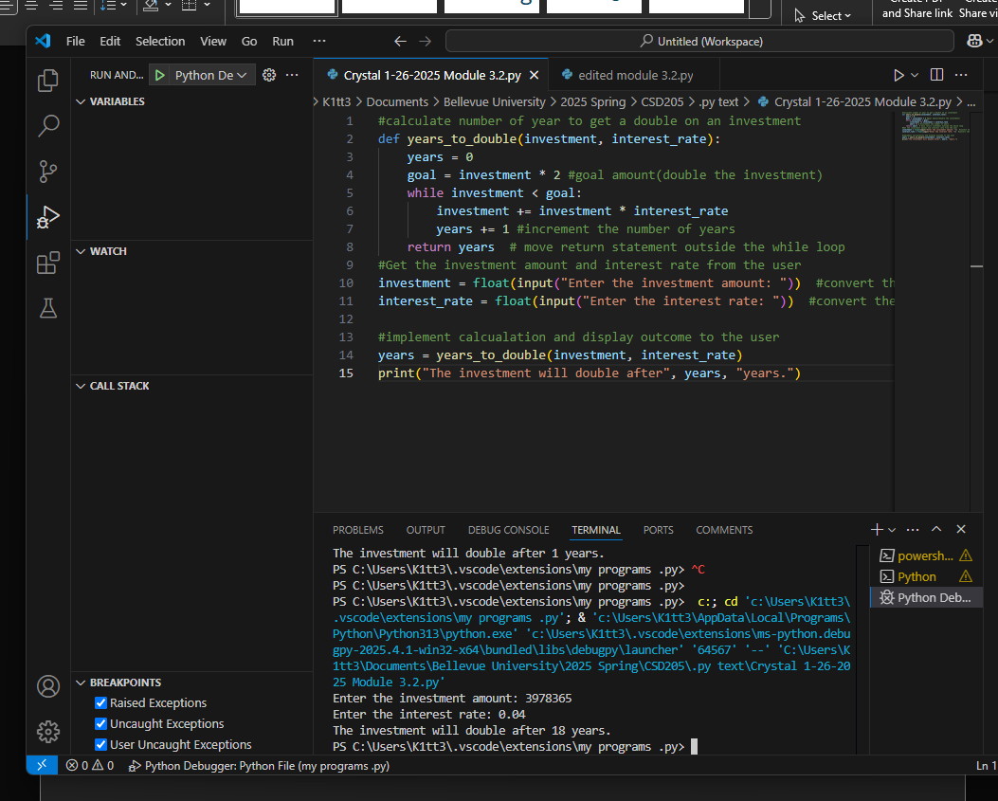

The debugging above

Breakpoint added and debugging started

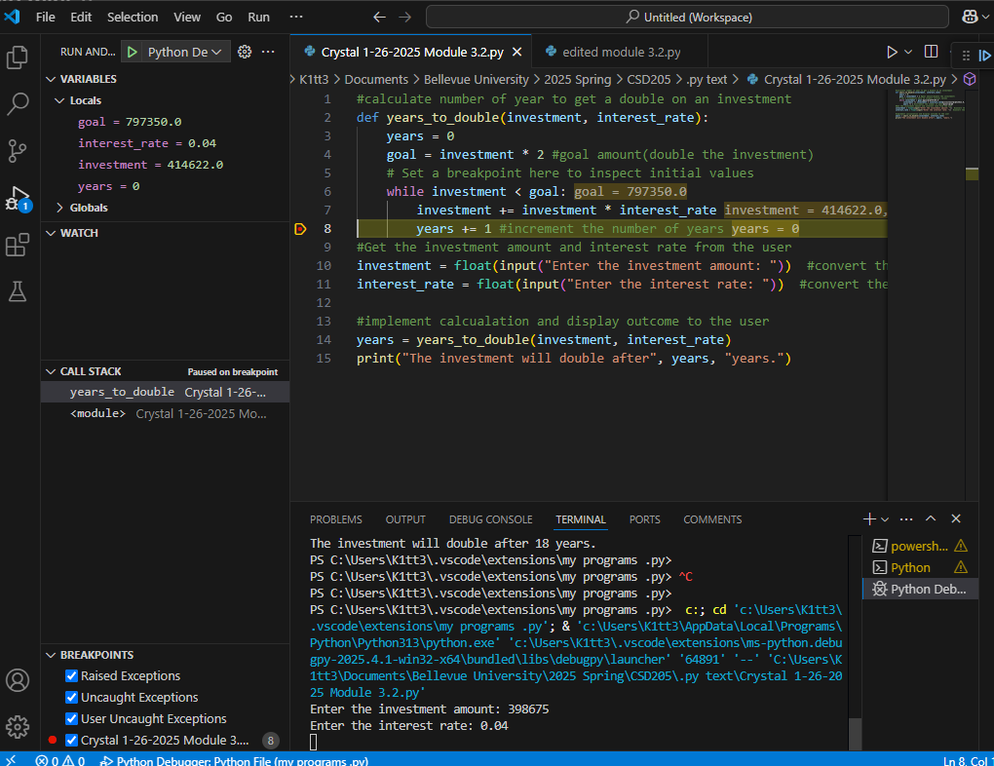

Stepped into the function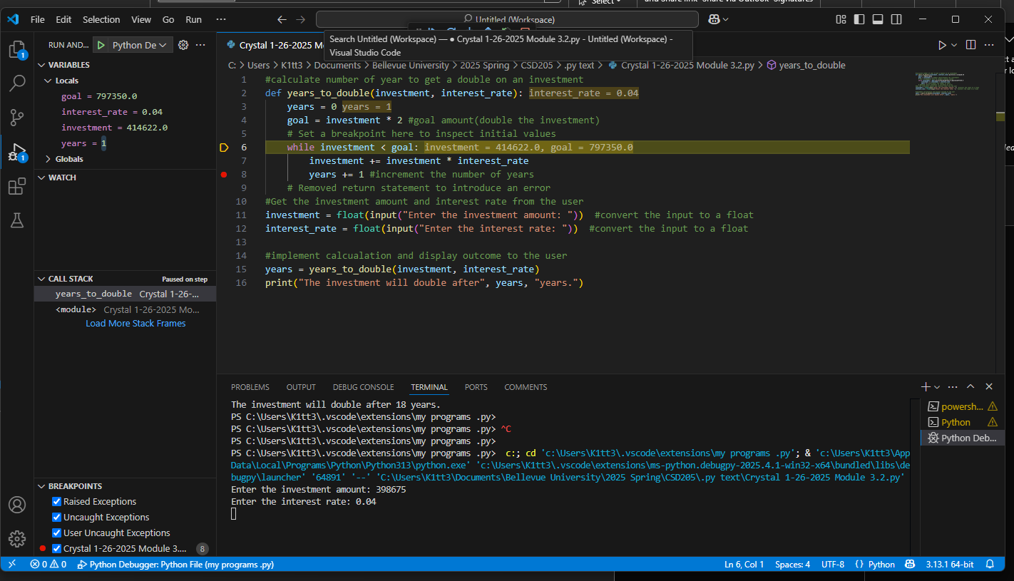

I removed the return statement so that an error was added into the code.